St John’s Church Hall. Snods Edge. Shotley Bridge. DH8 9TJ.
OS ref: NZ065535. Global co-ords N54° 52’ 4” W 1° 54’ 3”

Saturday 21st March 2020 at 10:00 am.

The guest speaker for this meeting is Sheila Graber.

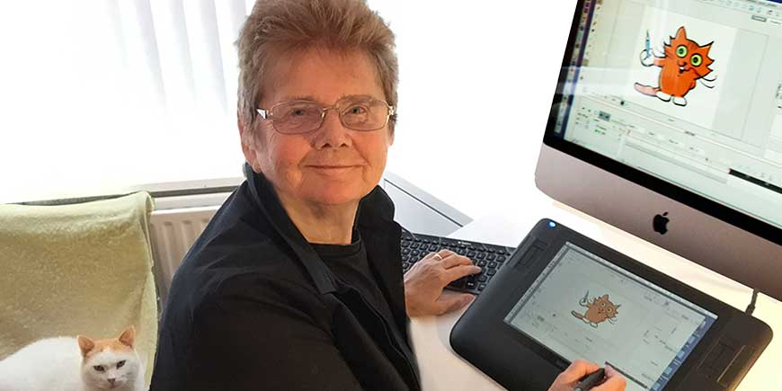
Born and raised in South Shields, Sheila graduated from Sunderland College of Fine Art and began a career in teaching in Birmingham. She started animation in 1970 and produced a series of short programmes which were distributed world-wide. One film about the Dutch painter Piet Mondrian was screened at the Tate Gallery and on BBC’s Blue Peter. This lead to Sheila creating the animation for Paddington Bear and Mr and Mrs Brown for the BBC television series ‘Paddington’. From there, came the "Just So Stories" in 1980 — a 10-episode series based on Rudyard Kipling's classic tales.
Sheila took a position at the University of Teesside, as the Animator in Residence before accepting the role of Senior Research and Teaching Fellow in Animation at Sunderland University where she was awarded an Honorary Fellowship for Outstanding services to Education and Art. Sheila still holds the position of visiting Professor to the University of Sunderland. She has created over 60 shorts and three series for World TV including the BBC and holds many awards for her work including the Royal Television Society Best Digital Designer and she is an Honorary Fellow of the IAC. With experience ranging from cell animation to digital creation, Sheila is perfectly qualified to be talking to the NAVGroup about how we can prepare and include animation in our AVs and she has entitled her talk ‘Animation as Communication… and a Cat.’ As Sheila says, “I will outline how I have set about animation from Super 8 film in 1973 to present day iPad in order to communicate ideas and encourage others to do the same. A cat has been and still is my constant companion on this journey.”

Cost: - £14.00

Arrival, morning, lunchtime and afternoon tea or coffee are included in this price.

Lunches can be provided at £7.00 each but they must be ordered in advance (see the reply slip below). If you prefer to bring your own lunch, you are still welcome to have tea and coffee if you wish to do so.
All bookings must be received at least 7 days before the meeting, even if lunch is not required.
Attendees Sequences

There will be the usual opportunity for attendees to show their own AVs produced with Pictures To Exe or ProShowGold, to an appreciative audience who will have the opportunity to comment on a time-limited basis. Please note that sound and picture reproduction in the hall is unlikely to be the same as that produced by your own home equipment and that we cannot adjust the hall equipment to suit individual sequences.

For this meeting will you please submit your sequences to Stuart Edgar. Send your executable file to Stuart using ‘WeTransfer’ – https://www.wetransfer.com following the web site instructions and using Stuart’s email address stuart.edgar2@btinternet.com. If this is not possible, send the executable file on CD or Memory Stick to Stuart at Stuart Edgar, Greensyke, Kirkbampton, Carlisle, CA5 6HX.

To allow time for your AVs to be prepared for screening and for the programme for the day to be arranged, all sequences must be with Stuart by Friday 13th March. Any sequences arriving after this date cannot be compiled and therefore may not be screened. Sequences will be accepted in the order in which they are received.

Payment Details

1. Payment by internet banking. Please use this method if possible.

To help with administration I would like to receive payment and the booking form details no later than Friday 13th March 2020 even if lunch is not required.

Bank details. Sort Code: 40-16-22 Account number: 02383527
On the same day that you make the bank transfer send an e-mail to me at: pandj@uwclub.net providing the details shown on the booking form below. Or send me a completed booking form as an attachment to the email.

2. Payment by cheque.

Send a cheque and a copy of the booking form below by post. I must receive these by Friday 13th March 2020 even if lunch is not required.

Please make cheques payable to The Northern Audio-Visual Group and send your completed booking form and cheque to:

Mr Paul Hogarth. 11 Conniscliffe Road. Hexham. NE46 2LW. Tel: 01 434 606947.

Please enclose an SAE if directions to Snods Edge and/or an acknowledgement are required.

3. Payment at door.

If you wish to do so you can just turn up and pay at the door, but you will not then be able to have lunch or enter a sequence.

You can find further information on our website www.thenorthernavgroup.co.uk

Booking Form: Please type (preferably) or print legibly.

Northern Audio Visual Group Meeting Saturday 21st March 2020.

I / We will be attending the Northern Audio Visual Day on Saturday 21st March 2020.

Do you have a sequence to show? Please circle: YES NO

If ‘YES’ please give the TITLE

And DURATION min sec

NB Submission of any work implies that you have obtained licences or permissions to use any copyright material included in the sequence and agree that it can be sent to a named assessor for constructive critique.

Name(s) of all in group.

Contact address
including post code

e-mail

Telephone
number

Members

@ £14.00 each
£

Please reserve lunches

@ £7.00 each
£

£
Total

If you would like to begin to receive direct information about our events we will need your permission to place you on our current mailing list. Please complete an opt-in form available from our Secretary at the meeting.

Please also make sure that your up to date e-mail address is clearly shown above.

If this is your first meeting, I would be interested to know how you heard of us.

Paul Hogarth, (Treasurer)

