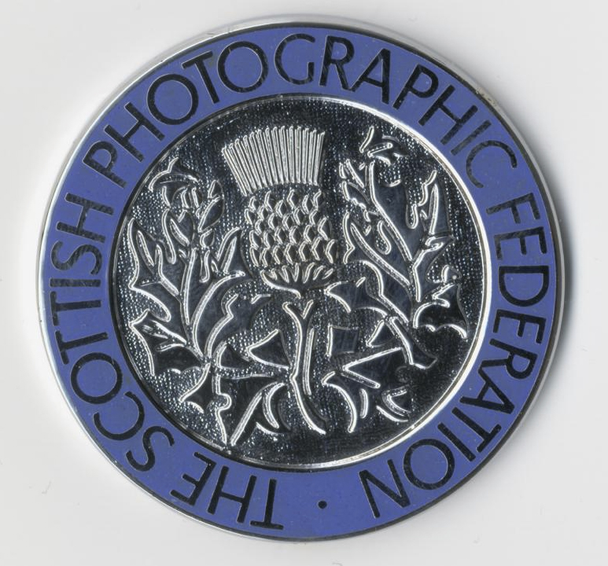
SPF Medals are available to purchase for your Club’s competitions, for end of year Annual Competitions or for Inter-Club events.

Silver and Bronze Medals are available for Club or Inter-Club use.

Gold* Medals are available for National or International events only (not for Club or Inter-Club Competitions) *Gold Medals must be engraved before presenting. You are free to present Silver and Bronze Medals without engraving if you wish.

Should you require any assistance with your SPF Medals Order you can contact Joe Prior on 0141 883 3131 or Email: johnprior1@btinternet.com

If you would like to order SPF Medals for your Club, please complete this Order Form and send it together with your cheque made payable to ‘SPF’ to –

Joe Prior, SPF Admin Assistant, 24, Langcroft Road, Glasgow G51 4JB.

Please Note: Due to Covid restrictions there may be a delay on delivery of your medals so please let us know the date you require to receive them by. We will endeavour to get them to you as soon as possible.

CLUB NAME
Contact Name  Address  NB - A telephone number and email address must also be supplied in case of any queries. This will also allow us to keep you updated re your order. | .  .  .  .
Contact Tel.
Contact E-Mail

Please complete for the medals you require. P&P must be added to ALL Medal Orders at £4.50 per max 8 medals e.g., if you require 11 medals you must include £9 P&P. Please keep a copy of this ‘Invoice’ for your own records – Receipt of Medals will confirm receipt of payments. No other receipts will be sent.
Medal Type | Quantity | Cost Per Medal | Total Cost
GOLD MEDAL* See above note |  | £17.00
SILVER MEDAL |  | £15.00
BRONZE MEDAL |  | £15.00
P&P (per 8 medals)  e.g. if you require 3 medals include £4.50 P&P; if you require 11 include £9 P&P and so on. |  | £4.50
TOTAL CHEQUE AMOUNT
DATE MEDALS REQUIRED BY
Please make cheques payable to ‘SPF’ and send to Joe Prior at the above address.
Please Note – Electronic Transfer and Paypal methods of payment are not available for Medals

