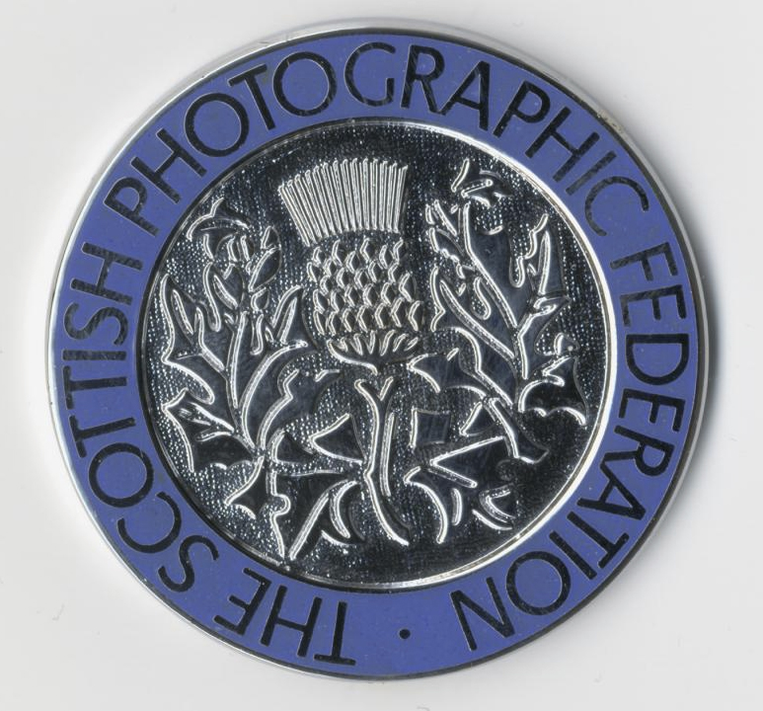

SPF Medals and Ribbons are available to purchase for your Club’s competitions, for end of year Annual Competitions or for Inter-Club events.

Silver & Bronze Medals are available for Club/Inter-Club use. Gold Medals are only available for National or International events (not for Club or Inter-Club Competitions) *Gold Medals must be engraved before presenting. You are free to present Silver and Bronze Medals without engraving if you wish.

Should you require any assistance with your SPF Medals Order you can contact Joe Prior on 0141 883 3131 or Email: johnprior1@btinternet.com

If you would like to order SPF Medals for your Club, please complete this Order Form and send it with your cheque made payable to ‘SPF’ to –

Joe Prior, SPF Admin Assistant, 24, Langcroft Road, Glasgow G51 4JB.
Or to pay by BACS or PayPal please send your order form request to SPF Treasurer Libby Smith – libby.neilsmith@googlemail.com 01555 750737, 34 Braemar Cres., Carluke ML8 4BH

Please Note: There may be a delay on delivery of your medals or ribbons so please let us know the date you require to receive them by. We will endeavour to get them to you as soon as possible.

CLUB NAME
Contact Name  Address  NB - A telephone number and email address must also be supplied in case of any queries. This will also allow us to keep you updated re your order. | .  .  .  .
Contact Tel.
Contact E-Mail

Please complete for the medals you require. P&P must be added to ALL Medal Orders at £4.50 per max 8 medals e.g., if you require 11 medals you must include £9 P&P. Please keep a copy of this ‘Invoice’ for your own records – Receipt of Medals will confirm receipt of payments. No other receipts will be sent.
Medal Type | Quantity | Cost Per Medal | Total Cost
GOLD MEDAL* See above note |  | £17.00
SILVER MEDAL |  | £15.00
BRONZE MEDAL |  | £15.00
SPF Ribbons - 10 Pack |  | £15.00 (inc P&P)
P&P (per 8 medals)  e.g. if you require 3 medals include £4.50 P&P; if you require 11 include £9 P&P and so on. |  | £4.50
TOTAL CHEQUE AMOUNT
DATE MEDALS REQUIRED BY
Please make cheques payable to ‘SPF’ and send to Joe Prior at the above address.
Or to pay by BACS or PayPal please send to Libby Smith – libby.neilsmith@googlemail.com

