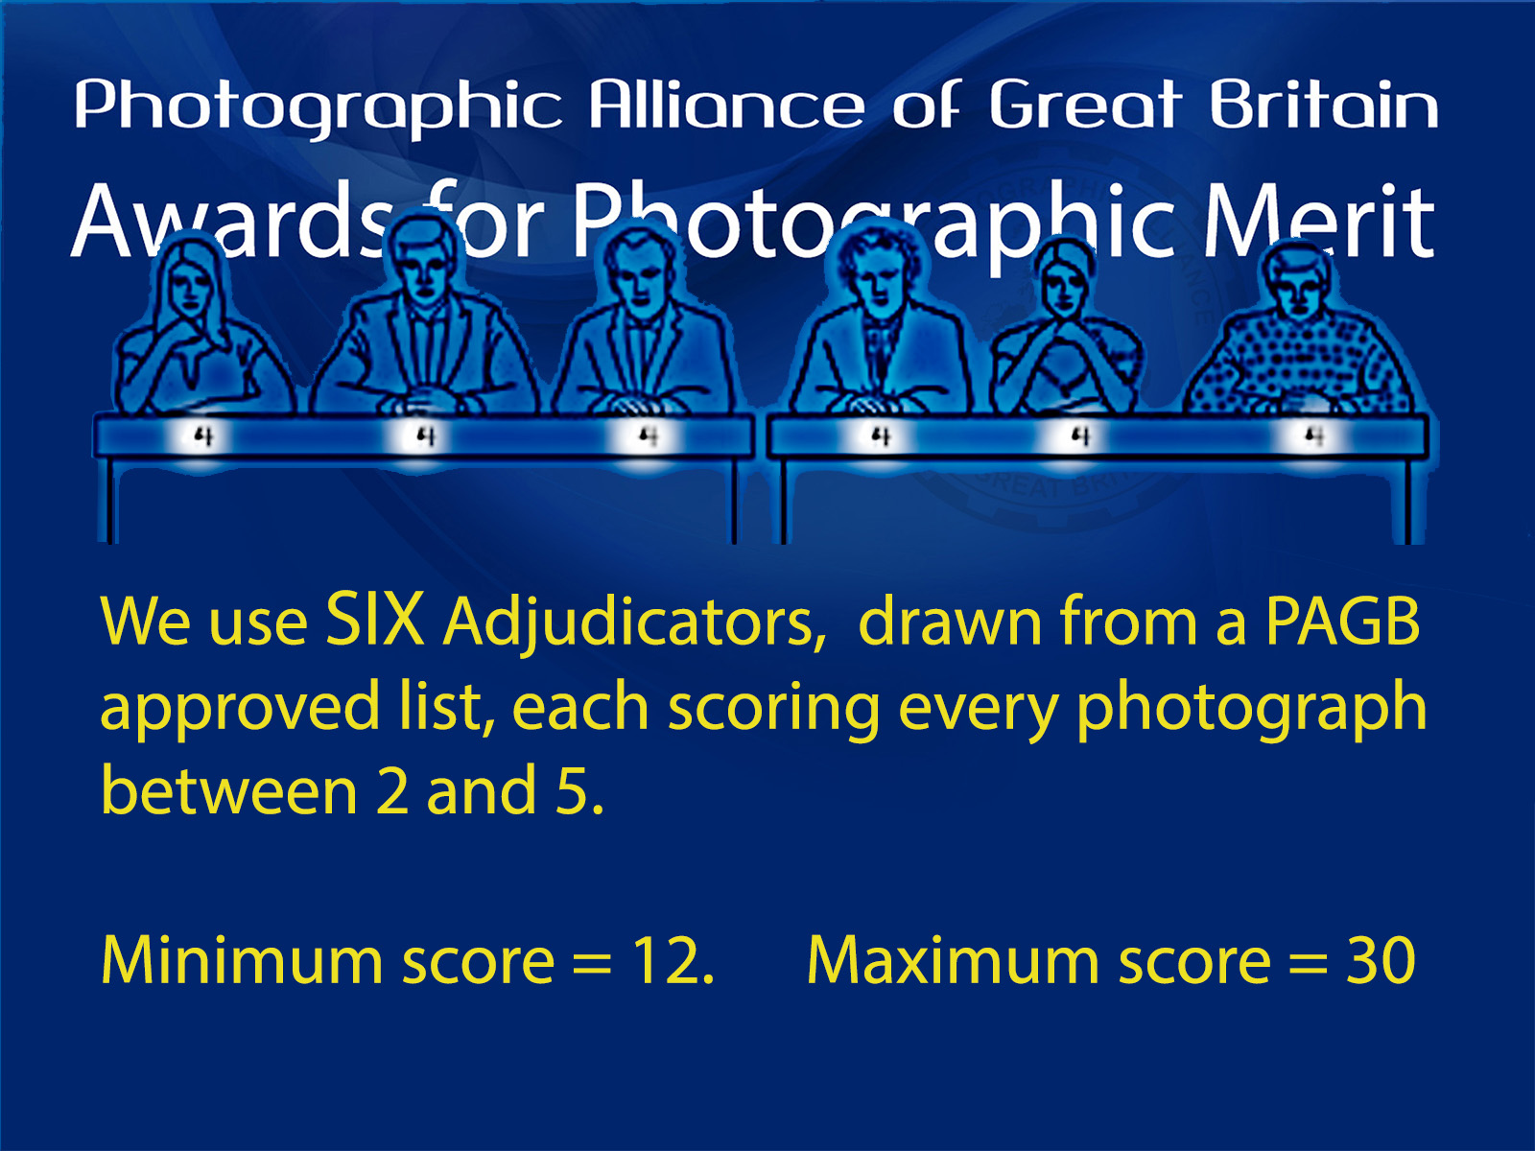
BPAGB - CPAGB – DPAGB – EPAGB – MPAGB
SPF PAGB Awards Workshop Day for assessment of Prints & PDIs on Saturday 13th Sept 2025
This is an all-day FREE event starting at 10.00am, and being run at the United Reformed Church Hall, Carluke, for individuals to have their prints and images assessed so spaces require to be pre-booked as soon as possible but by 10th Sept at the latest. We expect this workshop to be very busy, so please submit your booking form info as soon as you know you are able to attend. All SPF Club members are eligible to attend this; there is no pre-qualification requirements for attending this SPF workshop.
As there are no PAGB Awards Adjudications now until April 2026, with Nov 2025 being cancelled. Spaces for this workshop will be allocated on a first come, first served basis, with everyone able to have up to 7 photos assessed per assessor (i.e. 14 different photos if you wish). We plan to hold another workshop in time for those going for Apr 2026. We can accommodate some observers, but observers must also pre-book.
I will acknowledge receipt of your booking form and confirm you have a space on this workshop, as soon as I can confirm I have all required details from you. I will also supply full location details. The venue will open at 9.30am, and Tea/Coffee will be available shortly thereafter ready for the 10am start.
This event will be run in our normal format with stations of assessors giving critique on your work with regard to the level you have applied for or are thinking of applying for. You will be allocated two stations of assessors and time slots (one am and one pm), after that you can seek advice from anyone who is free at the end of each session. Prints do not require to be mounted. PDIs should be sized as 1600x1200 or smaller, and in a folder on a USB driver ready to be downloaded onto our laptop.
You are strongly recommended to register and bring work for assessment in the media you plan to apply for the distinction with, otherwise the comments given on the day will be of very limited value. You should plan to apply for the media you are best at. PDIs are not the easy option, and the greatest reason for individuals being unsuccessful are when print workers submit a PDI application rather than doing so with Prints. Those entering in PDI should ensure that they can regularly see their images projected on an 8’ screen on fully calibrated equipment.
The assessors who are attending, will include Rod Wheelans Chairman of the PAGB APMs & Libby Smith SPF’s PAGB Awards Officer and PAGB APM Sub-Committee member, together with other SPF APM assessors. Tea/coffee making supplies will be available for a donation. Bring your own packed lunch, or available from local vendors within easy walking distance.
To attend, you require to book your space as soon as possible to ensure a space, answering all of the questions given on the following booking form and send by email to - libby.neilsmith@btinternet.com by 10th Sept.
BOOKING FORM
Please feel free to copy the following into your email message rather than sending the form if easier
YOUR NAME
YOUR CLUB
(Must be an SPF Member Club)
LEVEL YOU ARE GOING FOR
(e.g. BPAGB, CPAGB, DPAGB, EPAGB, MPAGB)
PLEASE DELETE ONE OPTION FROM EACH OF THE FOLLOWING -
I WISH WORK ASSESSED AT THIS EVENT on Sat 13th Sept 2025 |  | YES/NO
IF ‘YES’ - I WILL BE BRINGING (i.e. the medium you are applying in) – you must bring only ONE medium. Contact Libby if you require advice before completing this section. |  | PRINTS/PDIS
IF ‘NO’ – I WISH TO OBSERVE ONLY |  | YES/NO
I HAVE ALREADY APPLIED FOR A FORTHCOMING PAGB AWARDS ADJUDICATION i.e. submitted a signed application form from Libby to the PAGB. |  | YES/NO
IF ‘YES’ – PLEASE INDICATE PAGB ADJUDICATION DATE IN 2026 |  | APR/NOV
IF ‘NO’ – PLEASE INDICATE WHEN YOU WISH TO APPLY FROM THE FOLLOWING |  | DON’T KNOW / APR 2026 / NOV 2026 /  2027 ADJUDICATION

Been on the PAGB’s website?
You also need to read this Leaflet for SPF Pre-Qualification Details (Stage 1) to find out how to be eligible for a signed PAGB Application Form from Libby, and submitting with payment to the PAGB for a space on a forthcoming PAGB Awards Adjudication (follow the link or copy to your browser)
https://www.scottish-photographic-federation.org/sites/default/files/downloads/spf_pre-qualification_and_pagb_awards_general_info_aug_2024_0.pdf
Also see PAGB Awards Leaflet 1 (V Dec 2023) for more on Stage 2 of the process
https://www.scottish-photographic-federation.org/sites/default/files/downloads/apm_leaflet_1_dec_2023_0.pdf
and PAGB Awards Leaflet 1 FAQ Supplement (V Jan 2024)
https://www.scottish-photographic-federation.org/sites/default/files/downloads/apm_leaflet_1-faq_jan_2024_0.pdf

NEED HELP? – HAVE QUESTIONS? – WANT TO FIND OUT MORE?
CONTACT LIBBY ON - libby.neilsmith@btinternet.com
OR for all up-to-date info about the PAGB Awards scheme visit the SPF website’s dedicated webpage
https://www.scottish-photographic-federation.org/pagb-awards-applying
OR for loads of successful SPF applicant’s galleries
https://www.scottish-photographic-federation.org/pagb-awards-results

